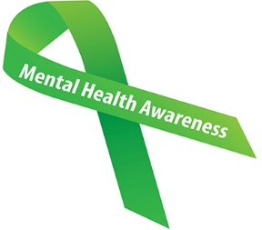
ARE YOU AGED 25 OR UNDER? FEELING ANXIOUS, UPSET OR NEED SUPPORT?

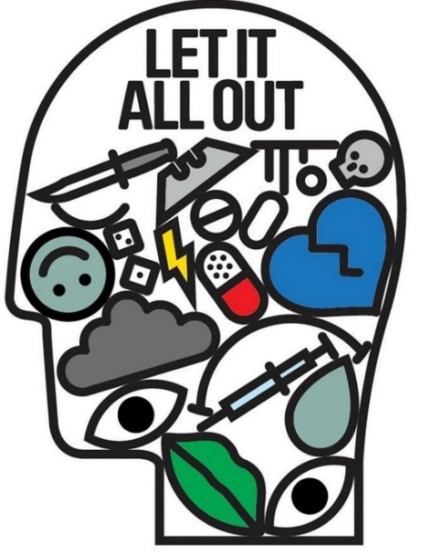
Pick up this flyer to find out more about services available for young adults
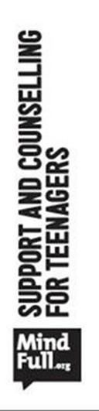

Your GP is here to help or you can speak to any member of the team
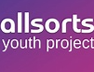
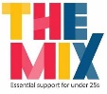
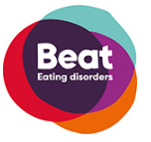
YMCA Mediation Service:
If there are arguments at home, we can help. The YMCA offers a safe space for 14 to 25 year olds to talk, mediate, listen and help you work things out.
Telephone: 01273 624432
Email: YAC.familymediation@ymcadlg.org
https://www.ymcadlg.org/what-we-do/support-and-advice/youth-advice-centre-yac/

THE MIX;
The UK’s leading support service for young people. We are here to help you take on any challenge you’re facing- from mental health to money, from homelessness to finding a job, from break-ups to drugs.
Telephone: 0808 808 4994
Crisis Messenger: www.themix.org.uk

BEAT:
We’re here for you if you or someone you love is suffering from an eating disorder or symptoms. We help support people with eating disorders on their journey to recovery.
Helpline: 0808 801 0677 Student Line: 0808 801 0811
Youth Line: 0808 801 0711
https://www.beateatingdisorders.org.uk/
ALLSORTS Youth Project:
Allsorts is a project based in Brighton to support and empower young people under 26 who are lesbian, gay, bisexual, trans or unsure (LGBTU) of their sexual orientation and/or gender identity.
Telephone: 01273 721 211
https://www.allsortsyouth.org.uk/

TAPA:
A mental Health service for young people aged 14-25, offering advice and support to young people experiencing mental/emotion health problems or related issues.
Telephone: 01273 718680
http://www.socialsubcultural.com/ruok/?page_id=334

